 **13 Mar 2015** **The Weekly Bulletin of Rotary Club of Kathmandu Mid-Town** **bc-35/3.015**

|  |
| --- |
|  |

District: 3292 Web:www.rotarymidtown.org.np Club Id: 26776

**MARCH IS THE LITERACY MONTH**

**“Literacy is a key lever of change and a practical tool of empowerment**

**on each of the three main pillars of sustainable development:**

**economic development, social development and environmental protection.”**

*- Kofi Annan*

Club’s Weekly Meeting # 1269 Friday, 6 March:

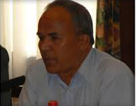

Extracts of the Meeting Minutes :

“1. Pres Kul Chandra called meeting #1269 to order.

“6. Pres Kul explained that our scheduled speaker Dr. Viquar Qurashi had been detained

by the closure of the Tribhuvan Airport and said that he was grateful to our own

member Rtn KB Rokaya who had graciously accepted to be the speaker at the last

moment. PP Komal gave the introduction. Rtn KB gave a very interesting talk

clarifying why in many respects he is 'one of the most misunderstood persons.' He

discussed his role in the peace process and how he had worked both through the

church and through his diplomatic contacts to make sure that all sides got a fair

hearing. A lively question and answer session ensued where the 'heady mix' of politics and religion was debated.

Rtn Werner gave the vote of thanks.

”7. Information sharing:

> Our meeting on Friday March 13th will be in two parts. The first part will be a celebration of Rotaract Week. The

second part will be a memorial for late PP Giri. If you have any special memories to share – please bring them on that

day. For different logistic reasons it had to be planned this way – please bear with us. Please note that on this day

the meeting will start at 7:45 AM..

> Reminder: Mid-Town Pot Luck Dinner on March 28, 2015. Rtn Bhairaja said that each Mid-Towner would receive 10

raffle tickets to sell. 500 Nrs per ticket. It would be ideal if each member sold at least 5 tickets. Many wonderful prizes

to be won including Grand Prizes: 2 nights for 2 at Tiger Mountain Pohara Lodge; 2 nights for 2 at Dwarika's

Himalayan Shangri-La Village Resort and airline ticket 'surprise' courtesy of Osho World Travel Nepal Pvt. Ltd.

> PP CK said that the birthing centre which is part of the wrap-up for the A&M project is now complete. This would be a

very good time for a visit by Mid-Town to finally close this project. Please be in touch with PP CK if you are interested

in attending.

> Rtn Mani said that there was now some funding available for 'ear screening' – interested parties please contact him.

> PP Gopal updated on the recent District Conference in Chitwan. There are still details that need to be sorted out for

the election of the DGN. He will continue to keep us posted.

> Rtn Sanjeeb commented on the recent Gopal and Kamala Rajbandari vocational award to Mr Joshi (who is 95 years

young!) and keeps in good health by walking an extraordinary number of kilometres per day.

> Exchange of flags with Rtn Isabel Jacobs (RC Antwerp, Belgium)

> Interested parties please contact PP Komal for the walk to Chitlang on Sat March 6.

“9. Statistics of the meeting: Members present: 28”.

# Weekly Meetings and Programs :

|  |  |  |
| --- | --- | --- |
| Date | Program/ Speaker | Topic of Presentation |
| 13 March | Rotaract week/  Late PP Giri’s memorial | First part: Short presentation by Rotaract President Sujan Manandhar.  Second part: a memorial for late PP Giri |
| 20 March | Dr Rup Khadka | Nepal tax system |

Weekly Meeting on Friday, 13 March:

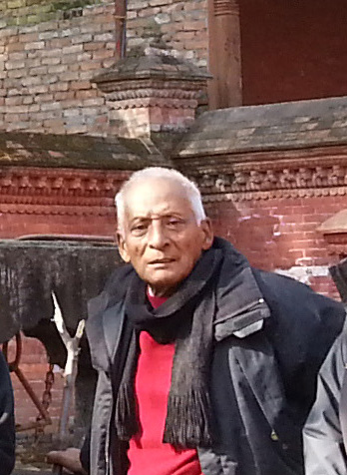

First part:

Celebration of ROTARACT WEEK. Short presentation by Rotaract president Sujan Manandhar.

Second part:

VP Lisa and PP Ambica to lead a remembrance of late PP Giri. Any Mid-Towners

who would like to share a few words of comfort or a happy remembrance of late PP Giri are

welcomed to come and share.

**Mid-Town Potluck Dinner on Saturday, 28 March 2015**

**Venue: At Rtn Sheri’s House (adjacent to the British School in Kupondole)**

It’s a potluck party and we should have a lot of fun.

The organizers expect each Mid-Towner to sell at least 5 raffle tickets of Rs 500 each.

Many wonderful prizes to be won including Grand Prizes: 2 nights for 2 at Tiger Mountain Pokhara Lodge;

2 nights for 2 at Dwarika's Himalayan Shangri-La Village Resort and

airline ticket 'surprise' courtesy of Osho World Travel Nepal Pvt. Ltd

Are you bringing something special (whatever) for raffle prize?

It would be better if you notify organizers in advance.

If you have not yet decided as to what you would be bringing,

simply send your entry without mentioning the item.

It would add more fun.

The winner will be in suspense as to what is it he/she’s getting!

**Highlighting Outstanding Rotarians this International Women’s Day, 8 March**

Thousands of women across Rotary, who work tirelessly on behalf of others, and whose efforts touch lives across the world, often in remote and inhospitable places, deserve recognition on International Women's Day. Some highlights:

**Ola Al-Awamleh Almasri**, RC Amman Capital: [Almasri](https://www.facebook.com/ola.alawamlehalmasri?fref=nf) helped build a water-catchment system for a public school in Jordan with a large enrollment of underprivileged students. She's also organized and supported vocational projects that train students to become entrepreneurs. She was recognized by Forbes as one of the top 50 businesswomen in the Arab world.

**Fary Moini**, RC La Jolla Golden Triangle: Over the last 10 years, [Moini](http://www.state.gov/p/io/unesco/members/49241.htm) has taken 19 trips to Afghanistan to work on projects ranging from school construction to setting up computer labs. Her fellow Rotary members called her "inspirational" in her involvement in the building of a school in Jalalabad, and in helping to provide neonatal and midwife training for medical professionals.

………More in Annex…….. *Source: RI News*

**Walking Circle members in Chitlang on Saturday 7 March**

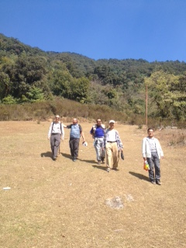 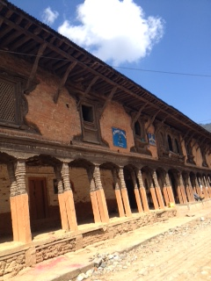 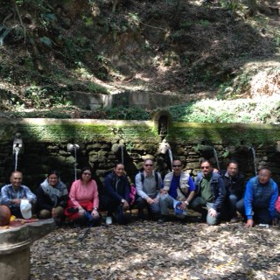

**Smoker slapped with fine for throwing butts!**

Singapore has fined a smoker S$ 19,800 for throwing cigarette butts out of his flat window, the National Environment Agency said, the highest ever such fine. The man was fined S$600 per cigarette for the first 33 offences, and ordered to do community service for the 34th, all committed within four days, the agency said. The 38-year-old smoker, who was caught on surveillance camera, will have to clean a public area for five hours wearing a bright vest bearing the words “Corrective Work Order”. Singapore, famous for its cleanliness, cracks down hard on even minor crimes like littering and vandalism, which is punishable by caning, and bans the import of chewing gum, in part to keep its public area spotless. The Agency said on its web-site it deployed surveillance cameras at nearly 600 locations and took 206 enforcement actions against offenders for high-rise littering in 2014.

*Source: The Himalayan Times*

On Lighter Side:

**A plumber attended to a leaking water tap at a neuro-sugeon's house.**

**After a 2-minute job, he demanded $75.  
"I don't charge this amount even though I'm a surgeon."  
"You're right - that's why I switched from surgery to plumbing!"**

**A THOUGHT FOR TODAY:**

**[The stupid neither forgive nor forget; the naive forgive and forget;  
the wise forgive but do not forget.](http://www.brainyquote.com/quotes/quotes/b/baruchspin101666.html" \o "view quote)**

[- Thomas Szasz](http://www.brainyquote.com/quotes/quotes/b/baruchspin101666.html" \o "view quote)

Travel / Tourism

Travelling is a great fun.







Share your Rotary stories. Tell them to your friends, on social media, and through

Rotary.org. Our Rotary stories are what inspire us, and what encourage others to join us;

they help light up our service, as we work to Light Up Rotary ?

**RI President GARY C.K. HUANG**

## 13 March 2015 The Weekly Bulletin of Rotary Club of Kathmandu Mid-Town bc-35/3.015

******************************************

Annex

Highlighting outstanding members this international women’s day

Thousands of women across Rotary, who work tirelessly on behalf of others, and whose efforts touch lives across the world, often in remote and inhospitable places, deserve recognition on International Women's Day, March 8. Some highlights:

**Ola Al-Awamleh Almasri, RC Amman Capital:** [Almasri](https://www.facebook.com/ola.alawamlehalmasri?fref=nf) helped build a water-catchment system for a public school in Jordan with a large enrollment of underprivileged students. She's also organized and supported vocational projects that train students to become entrepreneurs. She was recognized by Forbes as one of the top 50 businesswomen in the Arab world.

**Fary Moini, RC La Jolla Golden Triangle:** Over the last 10 years, [Moini](http://www.state.gov/p/io/unesco/members/49241.htm) has taken 19 trips to Afghanistan to work on projects ranging from school construction to setting up computer labs. Her fellow Rotary members called her "inspirational" in her involvement in the building of a school in Jalalabad, and in helping to provide neonatal and midwife training for medical professionals.

**Christina Covotsou-Patroclou, RC Limassol-Berengaria Cosmopolitan:** [Covotsou-Patroclou](https://www.facebook.com/christina.covotsoupatroclou?fref=browse_search) is a charter member of the Interact Club of Limassol, and helped launch the Rotaract Club of Limassol-Amathusia, the first Rotaract club in Cyprus. A former Paul Harris fellow, she worked with ShelterBox in 2006 to provide aid in Lebanon.

**Deepa Willingham, RC Santa Ynez Valley:** Willingham is founder and chair of [PACE Universal](http://www.paceuniversal.com/c/index.php/board)(Promise of Assurance to Children Everywhere), a nonprofit organization that educates girls in the world's poorest areas and works to prevent child trafficking. Working with Rotary clubs around the world, the center she formed provides education, microloans, health care, clean water and sanitation, and community infrastructure. "Together, we have created a site that is affecting the lives of 30,000 to 40,000 people," Willingham says.

**Teodora Alinsod Lucero, RC Santa Rosa Centro:** A midwife, Lucero is operating a birthing clinic that delivers an average of 500 babies a year. She also organizes a free medical clinic and workshop for pregnant women in underserved communities. In 2013, the National General Assembly of Midwives presented her the Gaward Agham Special Award for Excellence in clinical care.

**Carolyn Jones, RC Anchorage East:** The first woman to serve as a Rotary Foundation trustee, [Jones](http://alaskawomenshalloffame.org/2012/02/04/carolyn-jones/) has traveled to Russia as a Rotary volunteer five times, three of them as a preschool teacher for developmentally delayed children in orphanages. But her volunteer efforts have taken her elsewhere as well: "In the 27 years that I've been a Rotarian, I've administered polio drops in India, planted trees in Brazil, promoted microcredit in Costa Rica, and delivered baby formula in Uganda," Jones says.

**Bernadette Blackstock, RC Glassboro Sunrise:** The CEO of People for People Foundation,  [Blackstock](https://www.linkedin.com/pub/bernadette-blackstock/b/45a/bb1) helps normally self-sufficient people who have fallen on hard times to afford food, clothing, rent, utilities, medications, and other life necessities. "Since 2003, our foundation has served over 10,000 families," Blackstock says.

**Ginger Vann, RC Baker:** [Vann](https://www.linkedin.com/pub/ginger-vann/33/469/336) coordinates a tutoring program for at-risk students. With the help of her club, she renovated a derelict school building and worked with tutors to reach 50 students a day. She's also passionate about workforce development in Baker, where well-paying craftsman jobs often go unfilled. "We're not going out there and finding just anybody; we're targeting the unemployed, underemployed, and veterans," Vann says.

With projects focused on [child and maternal health](https://www.rotary.org/en/learning-reference/about-rotary/maternal-and-child-health), [economic development](https://www.rotary.org/en/learning-reference/about-rotary/economic-and-community-development), and other humanitarian concerns, these women are proof of Rotary's diversity and [global reach](https://www.rotary.org/en/learning-reference/about-rotary/areas-focus).